Zoo database table structures

The database is managed using Xampp (it’s a open-source software )

Admin table

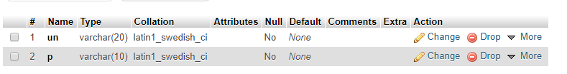

Staff table

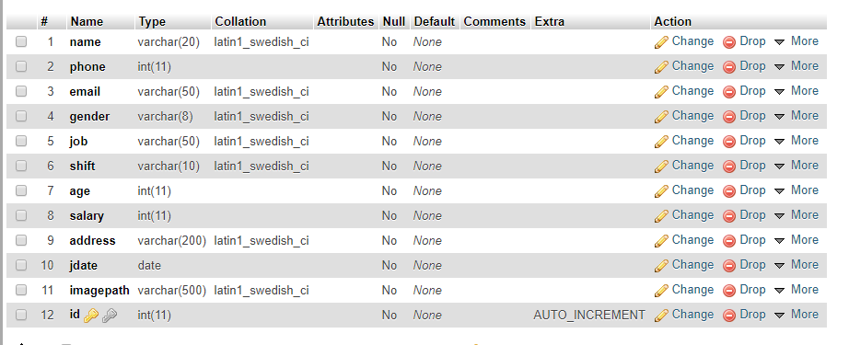

Donor table

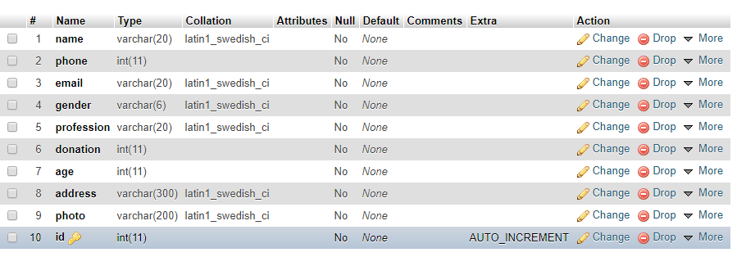

Animal table

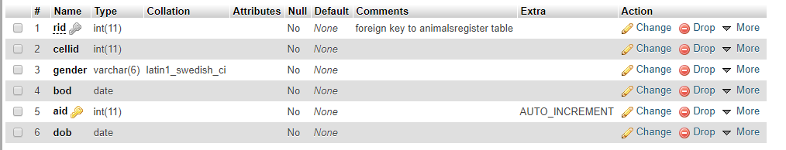

Animals register table

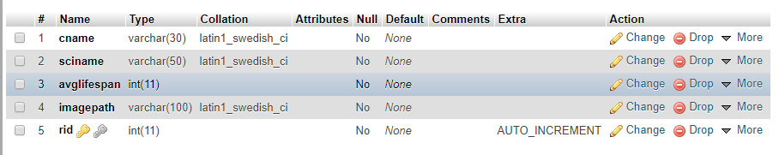

Cell table

